# Fibonacci number

# Coin change problem

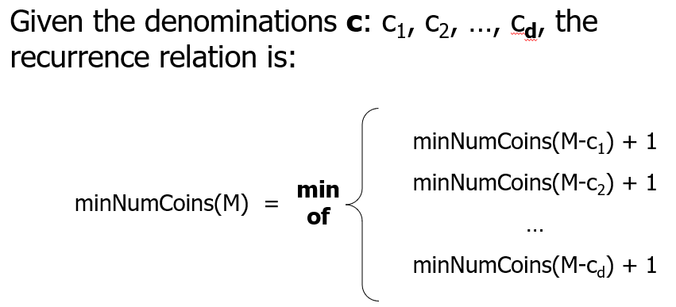

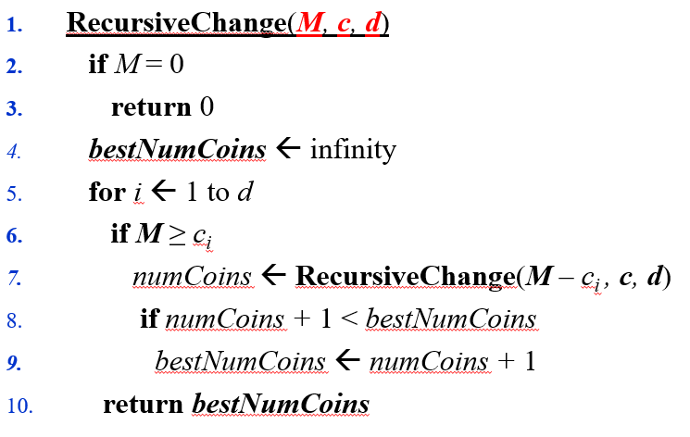

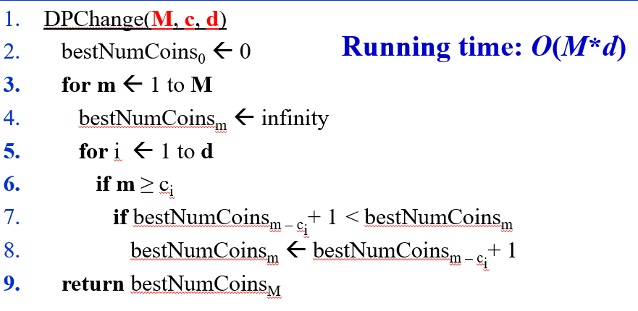

# Rod cutting

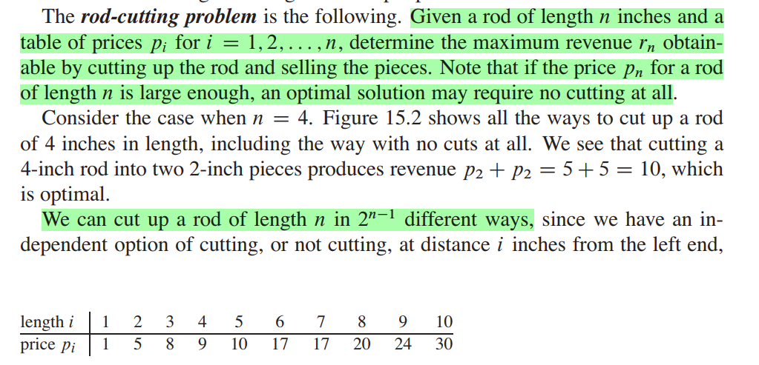

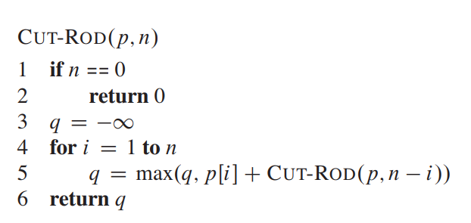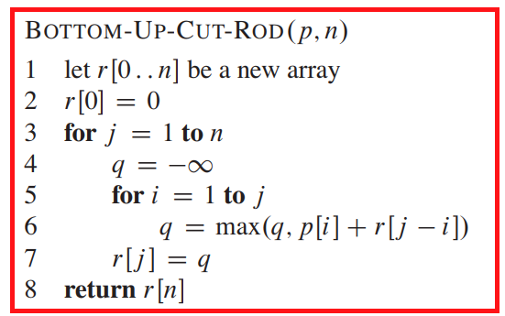

# Knapsack

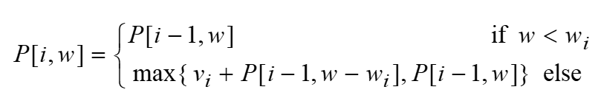

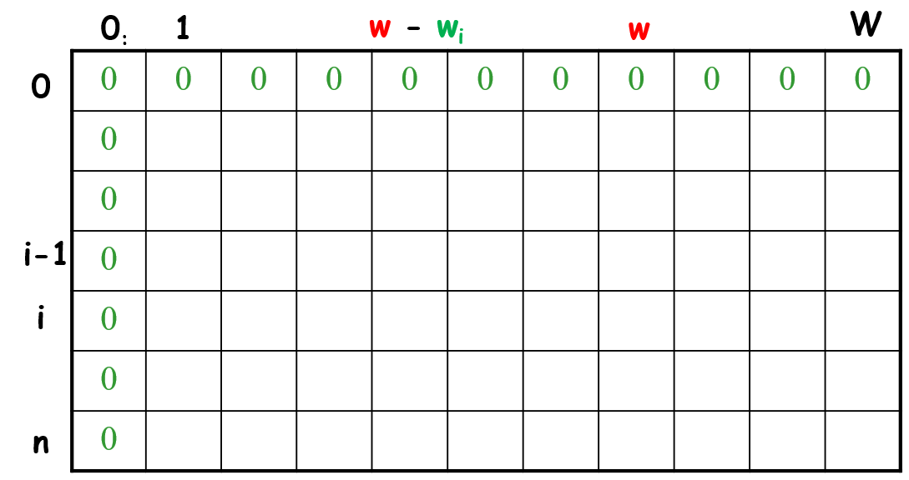

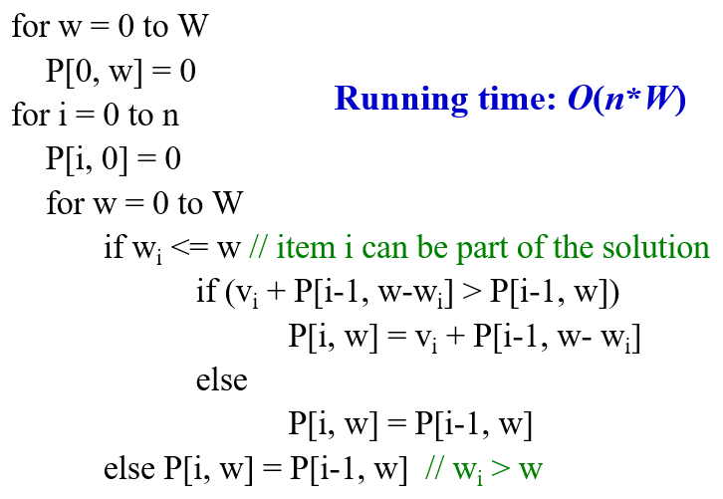

# Subset sum problem

You are given an array A and a number N. You need to find out if N is a sum of any subset of A or not.

*Example:*

A = {2, 4, 5, 6, 8}, N = 15 🡪 True {4, 5, 6}

A = {2, 4, 5, 6, 8}, N = 0 🡪 True {}

A = {2, 4, 5, 6, 8}, N = 3 🡪 False

Hint: similar to 0-1 knapsack. Think of A as set of items, N as knapsack capacity.

# Longest common subsequence

Given two strings x and y, find the longest common subsequence and its length.

*Example:*

x = “A**BCB**D**A**B”

y = “**B**D**C**A**BA**”

longest common subsequence = “BCBA”

longest common subsequence length = 4

x = “**AB**B**ACQ**”

y = “X**A**YZM**B**NN**A**LQ**C**TR**Q**”

longest common subsequence = “ABACQ”

longest common subsequence length = 5

Hint: CLRS 15.4

